CSA1509-Cloud computing and big data analytics
Experiment-9
Create a simple cloud software application for Health Care information system for
ABC Health Care using any Cloud Service Provider to demonstrate SaaS with fields of
patient name, age, address, phone, email, Attender name, attender phone, doctor name,
diseases, etc.
Input
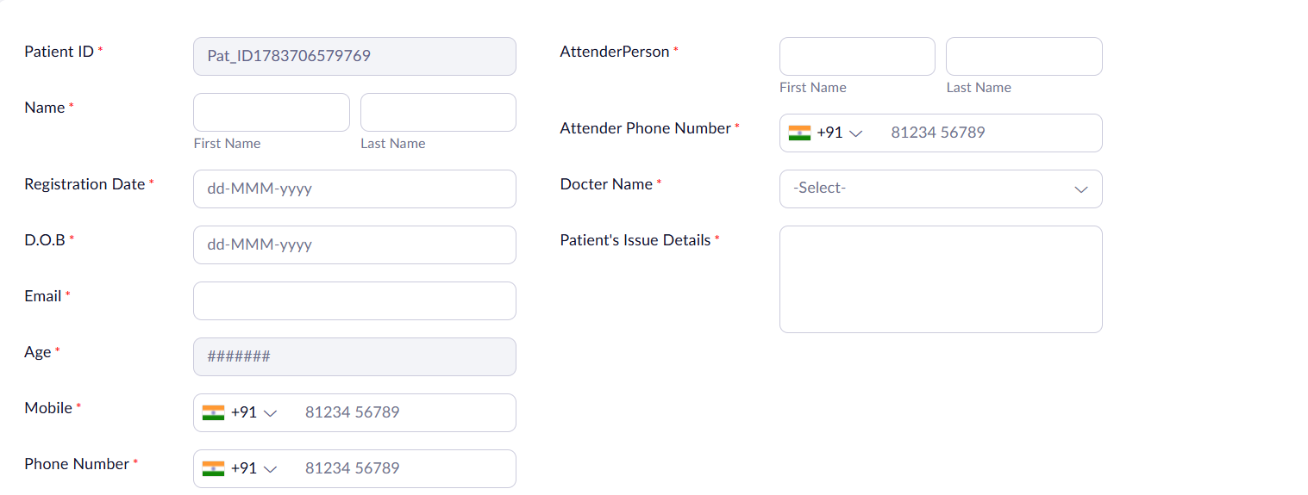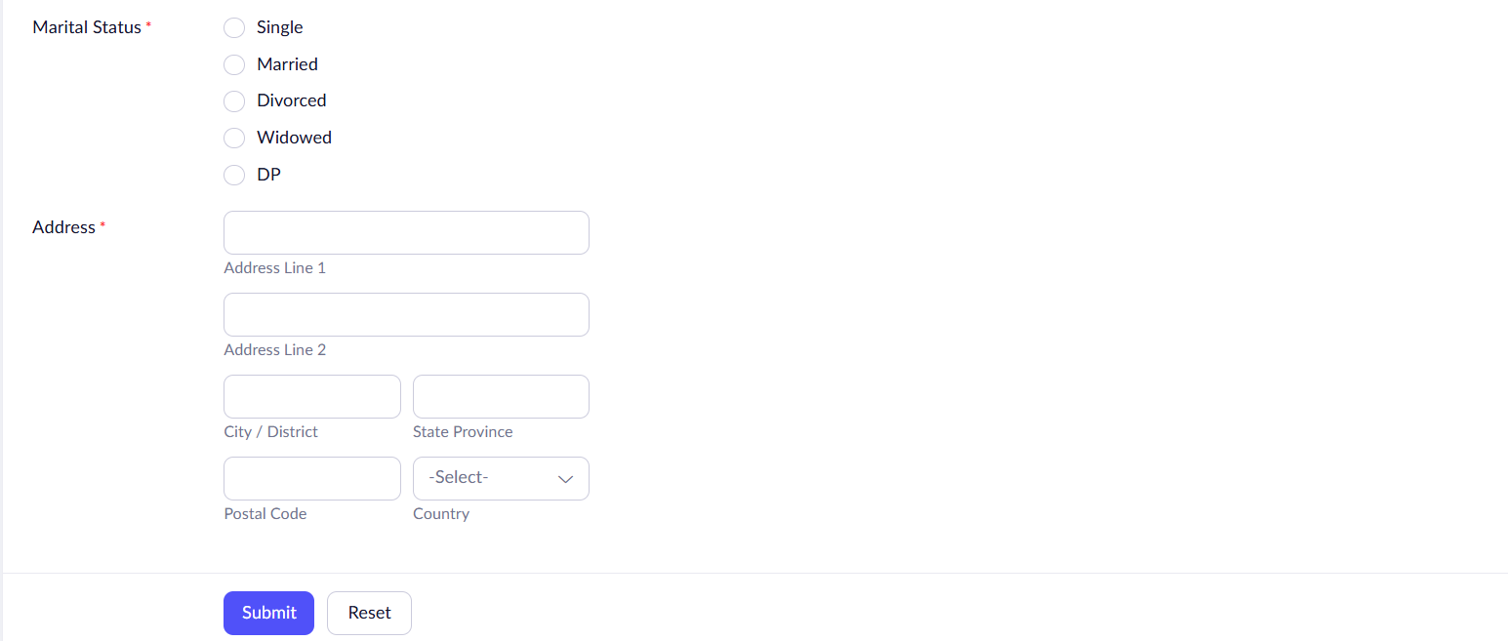
Output
